# POWER BI LAB - LAB 3_Data Visualization, Analytics, Charts, and Dashboards I

# THEORY: Visualization types in Power BI

The latest list for the available Power BI visuals is here:

<https://learn.microsoft.com/en-us/power-bi/visuals/power-bi-visualization-types-for-reports-and-q-and-a>

For a growing list of ready-made visualizations developed by third parties and available to you use in your own dashboards and reports out the Microsoft AppSource.   
 <https://appsource.microsoft.com/marketplace/apps?product=power-bi-visualswhere>

# LAB 3A: Create a Gauge chart

A radial gauge chart uses a circular arc to show how a single value progresses toward a goal or a Key Performance Indicator (KPI). The gauge line (or *needle*) represents the goal or target value. The shading represents the progress toward the goal. The value inside the arc represents the progress value. Power BI spreads all possible values evenly along the arc, from the minimum (left-most value) to the maximum (right-most value).

The following example shows a radial gauge chart for tracking car sales.

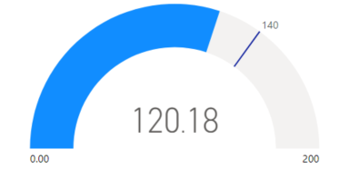

In this example, a car retailer is tracking the sales team's average sales per month. The gauge needle represents the sales goal of 140 cars. The minimum sales average is zero and the maximum is 200. The blue shading shows that the team is averaging approximately 120 sales this month. They have one more week to reach the goal.

## When to use a radial gauge

Radial gauges are a great choice in many scenarios:

* Show progress toward a goal.
* Represent a percentile measure, like a KPI.
* Show the health of a single measure.
* Display information that's easy to scan and understand.

## Download the sample data

Download the **Financial Sample** Excel file from Datasets Folder.

## Create a Gauge Chart

1. Start Power BI Desktop. At the bottom left of the screen, rename the default “**Page 1**” to “**Gauge Chart**”.
2. In Power BI Desktop on the ribbon, select **Get Data**.
3. Browse to select the **Financial Sample Excel** file, and then select **Open**.
4. In the "**Navigator**" screen, select the "**Financials**" sheet and click **Load**. The **Financial Sample** Excel file opens in report view. 
5. In the **Data** pane, expand **financials** and click on the **Gross Sales** checkbox. By default, Power BI creates a clustered column chart to display the data. On the **Visualizations** > **Build** visual pane, the **Y-axis** option is aligned to the **Sum of Gross Sales** value. Notice that by default, Power BI shows the *sum* value for the selected field.

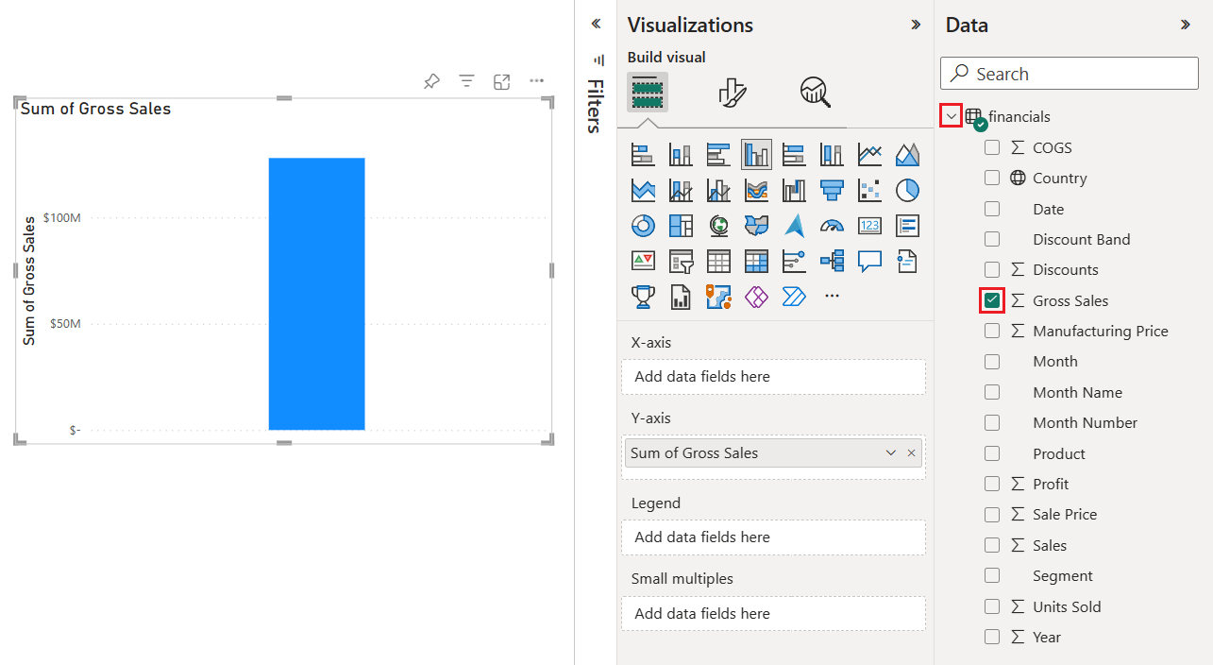

1. In the Visualizations pane, in the “Build Visual” tab click on the drop-down menu for the Sum of Gross Sales value under the Y-axis option and select Average. This action changes the aggregation for the chart to use the average of gross sales rather than the sum.

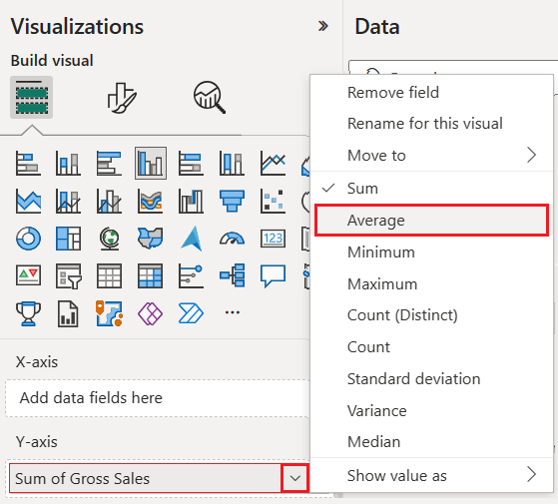

1. Now, we will change the chart visual to a Gauge visual. Click on the chart visual to select it, and then select **Gauge** in the **Visualizations** pane. Notice the changes to the **Visualizations** pane. The **Average of Gross Sales** value is now listed under the **Value** option. Several other value options are listed, including the **Minimum**, **Maximum**, and **Target**.

By default, Power BI sets the current value (in this case, **Average of Gross Sales**) as the halfway point on the gauge. Because the **Average of Gross Sales** value is $182.76 K, the start point on the gauge (**Minimum value**) is set to 0. The end point on the gauge (**Maximum value**) is set to double the current value.

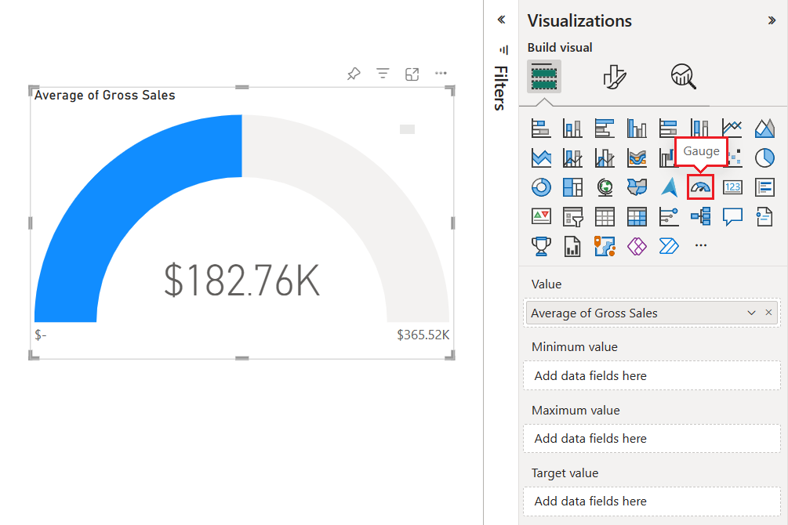

## Modify the target value of the visual

We will modify the gauge chart to show the target value of our sales. This action creates a *needle* on the gauge chart to identify this target.

1. Go in the **Data** pane and drag the **COGS** field to the **Target value** option on the **Visualizations** > **Build** visual pane. Power BI changes the chart view to show *Average of Gross Sales* and *Sum of COGS*.
2. In the **Visualizations** pane, in the “**Build Visual**” tab, in the **Target Value** field, click on the drop-down menu for the **Sum of COGS** value and select **Average**. By default, Power BI calculates the average of the two values *Gross Sales* and *COGS* to determine the target value. Power BI adds a needle to the gauge to represent the target.

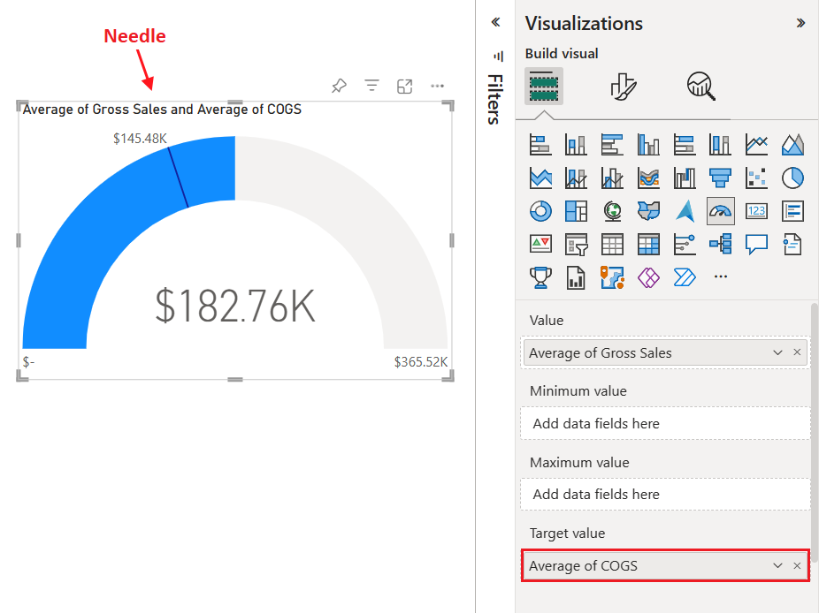

Power BI calculates the target value as $145.48 K. The position of the gauge needle shows that the average of the *Gross Sales* and *COGS* values exceeds the target.

You can manually specify a target value rather than using the calculation from Power BI. For more information, see the [**Use manual options to set values**](https://learn.microsoft.com/en-us/power-bi/visuals/power-bi-visualization-radial-gauge-charts?tabs=powerbi-desktop#use-manual-options-to-set-values) section.

**Set a maximum value for the Gauge visual**

Power BI uses the **Value** field in the **Visualizations** pane, in the **Build** **Visual** tab, to automatically set the minimum and maximum values for the gauge. You can use the values from Power BI or set your own. We will set our own maximum value here:

1. From the **Data** pane, drag the **Gross Sales** field to the **Maximum value** textbox in the “Build Visual” tab in the **Visualizations** pane.
2. Now, click the drop-down menu for the **Gross Sales** value and select **Maximum**.

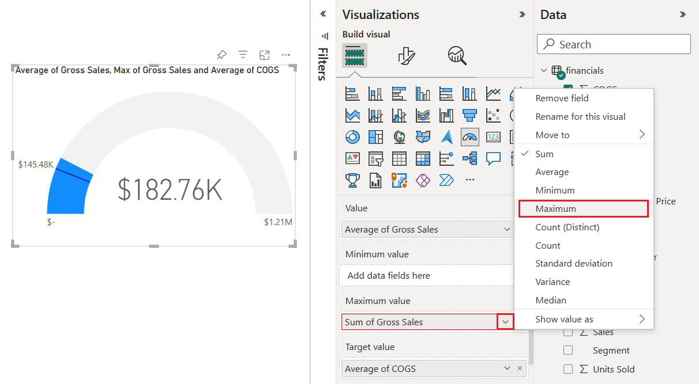

The gauge is redrawn with a new end value of 1.21 million in gross sales.

1. Save the report.

**Use manual options to set values for the Gauge Chart**

You will manually set values for the maximum, minimum, and target values for your gauge chart.

1. Remove the **Max of Gross Sales** field from the **Maximum value** textbox in the “Build Visual” tab.
2. Click on the “Format Your Visual” tab.
3. Expand the **Gauge axis** heading and enter values for the **Min** and **Max** settings to 100,000 and 250,000 respectively.

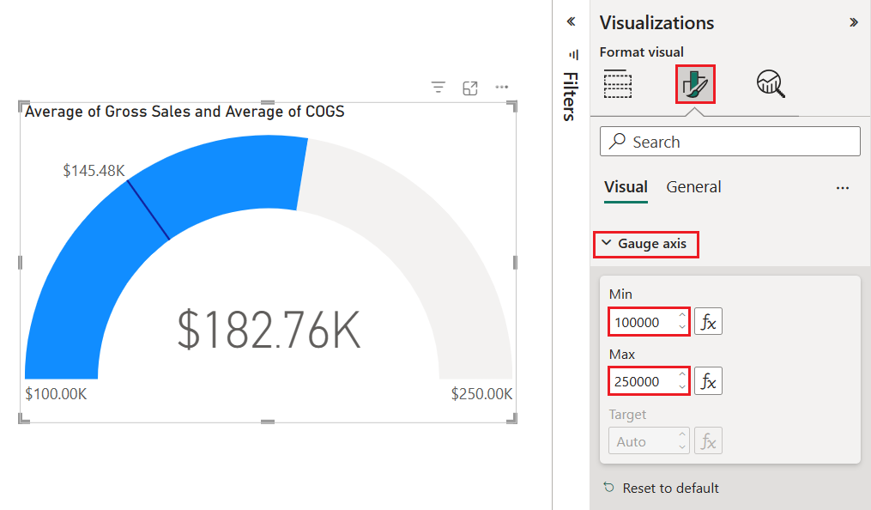

1. Make sure the Gauge visual is selected by clicking on it. In the **Data** pane, click the **COGS** checkbox to remove the target value from the Gauge visual.
2. In the **Visualizations** pane, in the “Format Your visual” tab, expand the Gauge axis and enter a **Target** value of 200,000. The gauge axis properties should look like the following:  
     
   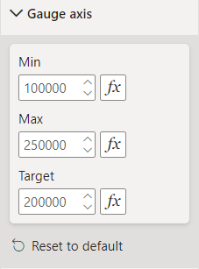
3. Change the color of the Target value: Click on the **Colors** heading to expand it and see its properties. Change the color of the **Target Color** to “Theme Color 5”.   
     
   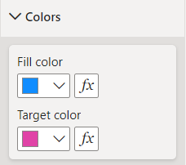
4. Change the color of the Target Label: Click on the **Target label** heading to expand it and see its properties. Change the Color property to “Theme Color 5”.  
     
   A screenshot of a computer

   Description automatically generated
5. Resize the visual to cover the whole page of the report. Your final visual should look similar to the one in the following image.

# LAB 3B: Create a Doughnut Chart

A doughnut chart is similar to a pie chart in that it shows the relationship of parts to a whole. The only difference is that the center is blank and allows space for a label or icon. Doughnut charts work best when you use them to compare a particular section to the whole, rather than comparing individual sections with each other.

## Create the Doughnut Chart

1. At the bottom left of the screen, click the plus sign to add a new page to the report. Name this page **Doughnut Chart**.
2. From the **Data** pane, expand the **Financials dataset** and then click the **Gross Sales** checkbox.
3. In the **Visualizations** pane, select the icon for doughnut chart  to convert your bar chart to a doughnut chart. If **Gross Sales** isn't in the **Values** section of the **Visualizations** pane, drag it there.

## Work with the Legend, Values, and Details fields of a Doughnut Chart

1. Make sure the Doughnut visual is selected. We select a visual by clicking on it. Drag the field segment on the Doughnut visual. Your visual should look like the one in the image below. In addition, the “Segment” field should appear in the **Legend** area of the **Visualizations** pane.   
     
   A blue circle with different colored circles

   Description automatically generated
2. Resize the visual to cover the whole page of the report.
3. To see Gross Sales within each Segment by Country, add the Country field to the **Details** textbox in the Visualizations pane.

## Adjust the font of the Legend

1. In the visualizations Pane, in the Format Visual tab, expand the **Legend** heading.
2. Within the Legend heading, expand the Text property. Change the font to Arial and the font size to 16.
3. Notice there is a position property as well to place the legend of the visual to the exact position you want.

Your chart should look like the following:

## Adjust the font of the Values

We notice in the visual that the values are not clearly visible. We will increase the font of those values to make them easier to see.

1. Make sure the visual is selected. In the visualizations Pane, in the “Format Visual” tab, expand the **Detail Labels** heading.
2. Within the Detail Labels heading, expand the Values property. Change the font size to 14.   
     
   A screenshot of a phone

   Description automatically generated
3. Your visual should look like the following:

## Setup Detail Labels

The issue we are facing now is that we do not know the category (in this case the country) to which the numbers of the gross sales refer to. For example, we have multiple segments within the Government sales but we do not know to what country each slice belongs to. We will correct this.

1. Within the **Detail Labels** heading, in the **Options** properties, change the **Label Contents** property to Category, Data Value. Your visual should now look like the following:   
     
   A blue circle with different colored circles

   Description automatically generated

Save your work.

# LAB 3C: Create a Scatter Chart

**Scatter charts** display data along a horizontal (x) and vertical (y) axis. The chart reveals how numerical values are related along the two axes. When data intersects on the two axes, Power BI displays a data point. You can analyze data points to identify relationships in your data. Data points are distributed evenly or unevenly across the horizontal axis depending on the chart data. Scatter charts work well in these scenarios:

* Show relationships between two numerical values.
* Show patterns in large sets of data.
* Compare large amounts of data points irrespective of time measurements.

## Create the Scatter Chart

1. At the bottom of the screen, click the plus sign to add a new page to the report. Name this page **Scatter Chart**.
2. From the **Data** pane, expand the **Financials dataset** and then click the **Gross Sales** checkbox.
3. In the **Visualizations** pane, select the icon for the Scatter chart to convert your bar chart to a Scatter chart. If **Gross Sales** isn't in the X-axis textbox, move it there. It should appear as **Sum of Gross Sales**.
4. Drag the field **Profit** to the Y-axis textbox. It should appear as **Sum of Profit**.
5. Drag the field **Product** to the Values textbox. It should appear as **Product**.
6. Maximize the Scatter Diagram to utilize the whole size of the report.
7. Move your mouse over the intersection points. You will see the sales amount, the profit amount, and the product to which these amounts refer to.

Your chart should look like the one in the image below:  
  
## Manipulate the Size of the Markers

The issue we have if we are to use this chart in a presentation is that the markers (intersection points) are very small. Let us change this:

1. In the **Visualizations** pane, click the **Format Your Visual** tab.
2. Expand the **Markers** heading and then expand the **Shape** property.
3. Change the size to 40.  
     
   A screenshot of a computer

   Description automatically generated

Your Scatter Diagram should now look like the following:

1. Collapse the Shape property so that its properties do not appear.

## Manipulate the Color of the Markers

It will be easier for us to distinguish the markers and make the visual more appealing by changing the colors of the markers:

1. In the **Format Your Visual** tab in the **Markers** heading, expand the **Color** property.
2. Set the Color by Category to On.  
     
   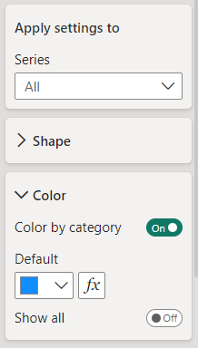
3. Collapse the Markers heading so that its properties do not show.  
     
   A screenshot of a phone

   Description automatically generated

## Add Category labels to the Scatter Diagram

1. In the **Format Your Visual** tab set the **Category label** to On.

This is how your visual should look like:

Save your work.